Supplementary S4: extra results for optimised multi-categorical rasters

The relative resistance values of the second, independent run are shown in figure S4.1, which is similar to figure 2 in the main manuscript. They qualitatively give similar and consistent results, especially the relative resistance values between anthropogenic (upper row Fig. S4.1 and Fig. 2) and natural landscape categories (bottom row Fig. S4.1 and Fig. 2). However, the comparisons *agric-opend*, *beach-opend*, *scrub-agric* (compare Fig. 2 and Fig. S4.1) are giving inconsistent results, so these relative resistance values should be considered inconclusive.

Table S4.1 is parallel to table 2 in the main manuscript, showing the summed Akaike weights for each category for each dune area cluster. Figures S4.2-S4.5 are parallel to figure 2 in the main manuscript, depicting the relative resistance values for the four dune area clusters. Both run 1 and run 2 are depicted.

Full tables for the bootstrap results can be found in supplementary S3 and S5.

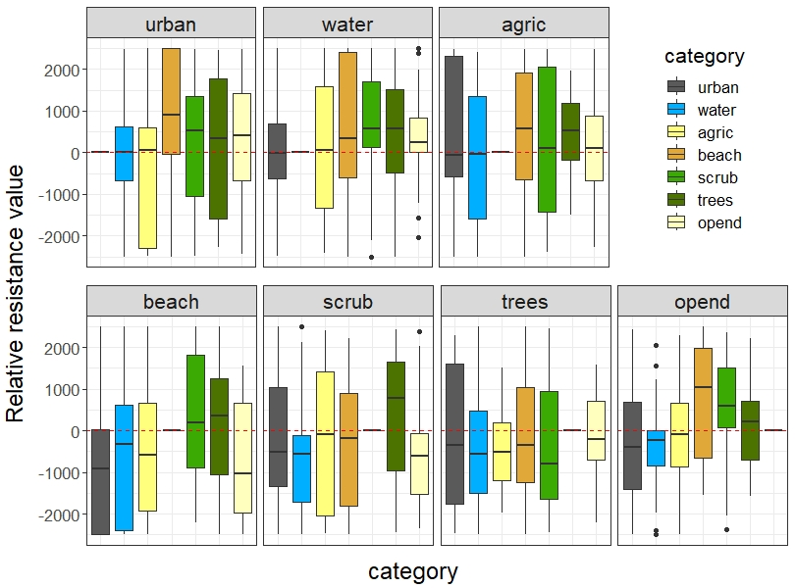

Figure S4.1: Relative resistance value from the second, independent optimization run of multivariate surfaces for the complete study area; run 2.

Table S4.1: Summed Akaike weights per category for multivariate surfaces (multiple categories optimizations) for the dune area clusters.

|  |  |  |  |
| --- | --- | --- | --- |
| **Dune area** | **Category** | **Sum weights** | **Sum weights run 2** |
| Westhoek | scrub | 0.551 | 0.537 |
| opend | 0.465 | 0.460 |
| beach | 0.434 | 0.408 |
| trees | 0.283 | 0.264 |
| urban | 0.280 | 0.266 |
| Cabour | agric | 0.341 | 0.331 |
| water | 0.231 | 0.228 |
| scrub | 0.207 | 0.201 |
| opend | 0.188 | 0.191 |
| trees | 0.187 | 0.191 |
| urban | 0.187 | 0.187 |
| Doornpanne | trees | 0.408 | 0.417 |
| opend | 0.307 | 0.311 |
| water | 0.271 | 0.264 |
| beach | 0.244 | 0.235 |
| scrub | 0.228 | 0.233 |
| agric | 0.226 | 0.237 |
| urban | 0.222 | 0.222 |
| Ter Yde | scrub | 0.266 | 0.271 |
| agric | 0.264 | 0.261 |
| trees | 0.258 | 0.258 |
| water | 0.257 | 0.254 |
| beach | 0.257 | 0.255 |
| urban | 0.252 | 0.257 |
| opend | 0.249 | 0.248 |

Notes: the Akaike weight for a model (optimized surface) was added to the summation (Sum weights) if the focal category (Category) was in it.

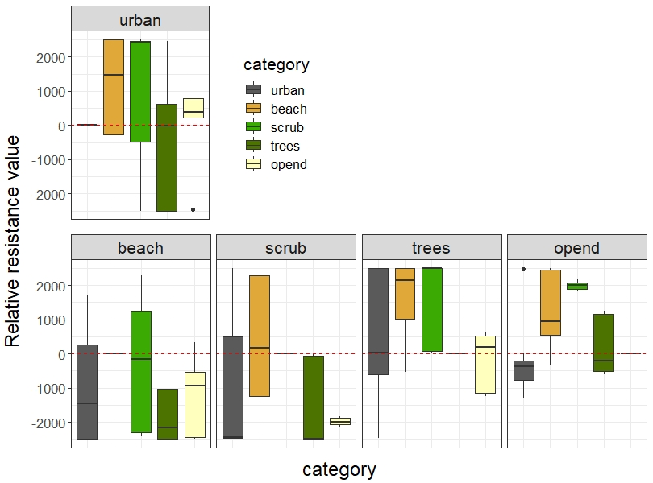

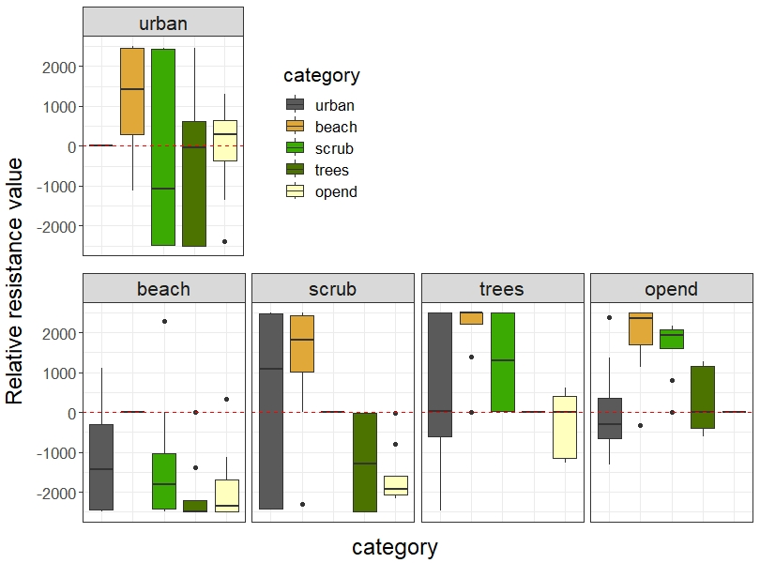

Figure S4.2: Relative resistance value from the optimization of multivariate surfaces for dune area cluster Westhoek; top: run 1, bottom: run 2.

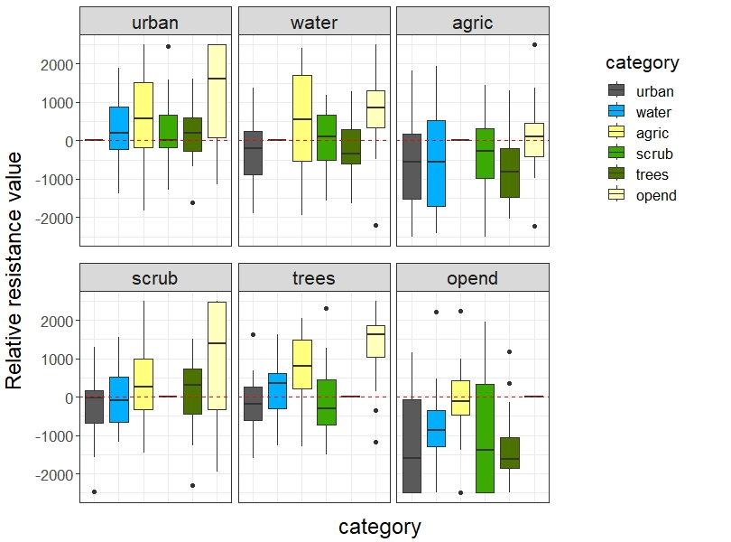

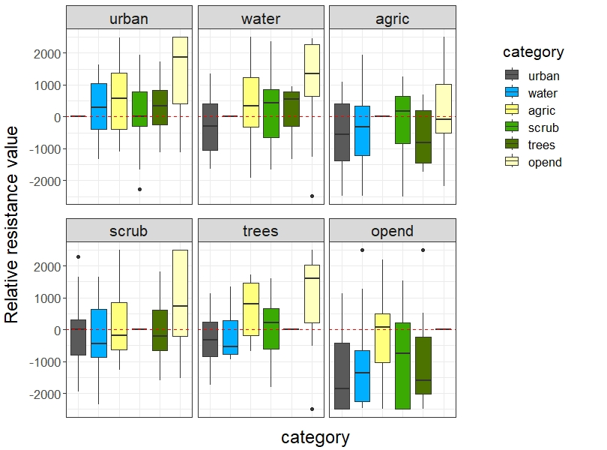

Figure S4.3: Relative resistance value from the optimization of multivariate surfaces for dune area cluster Cabour; top: run 1, bottom: run 2.

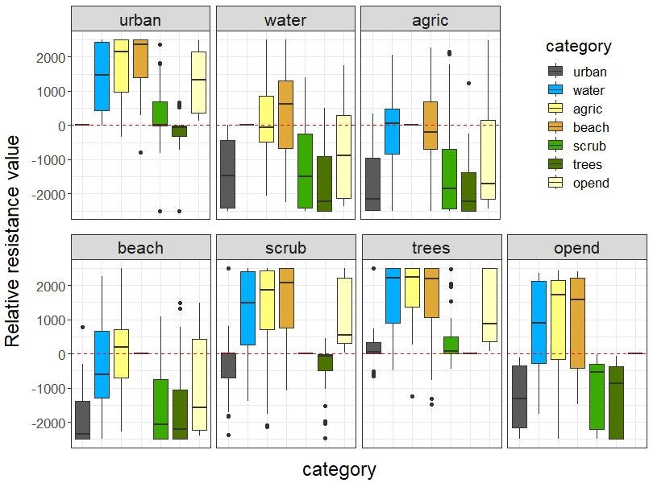

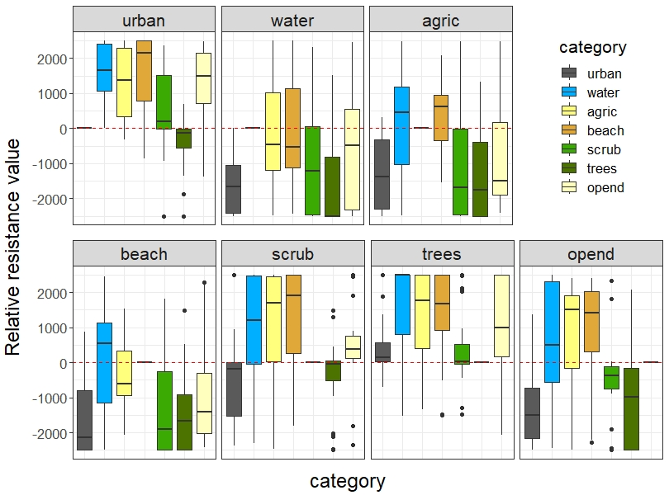

Figure S4.4: Relative resistance value from the optimization of multivariate surfaces for dune area cluster Doornpanne; top: run 1, bottom: run 2.

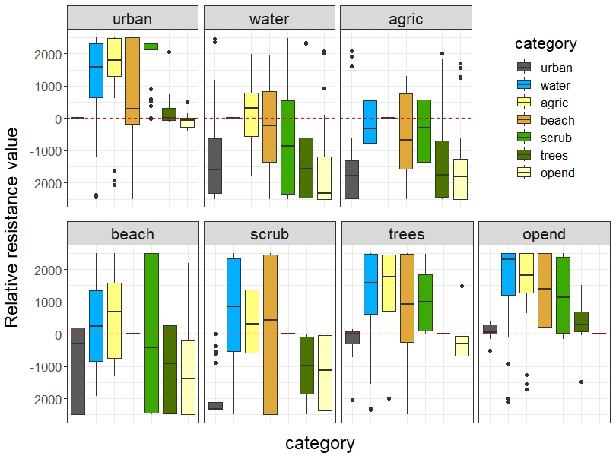

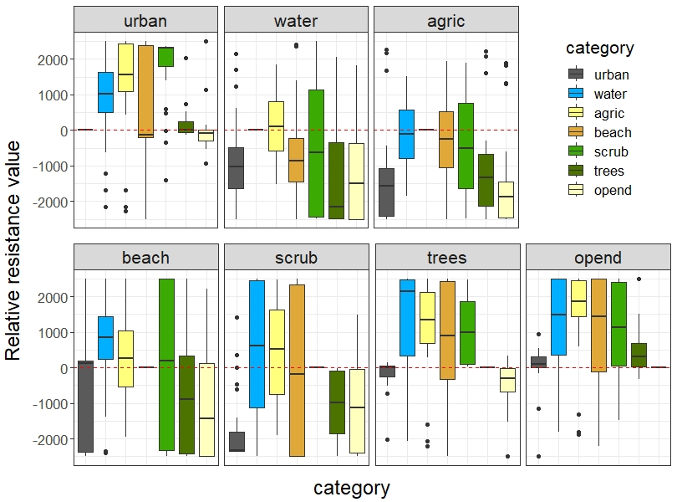

Figure S4.5: Relative resistance value from the optimization of multivariate surfaces for dune area cluster Ter Yde; top: run 1, bottom: run2.